Traditional chalet meets design
The Vera Apartments project in Andermatt combines traditional architecture with modern influences, using Bauwerk Parkett’s creative parquet collection Spinpark in its interiors.
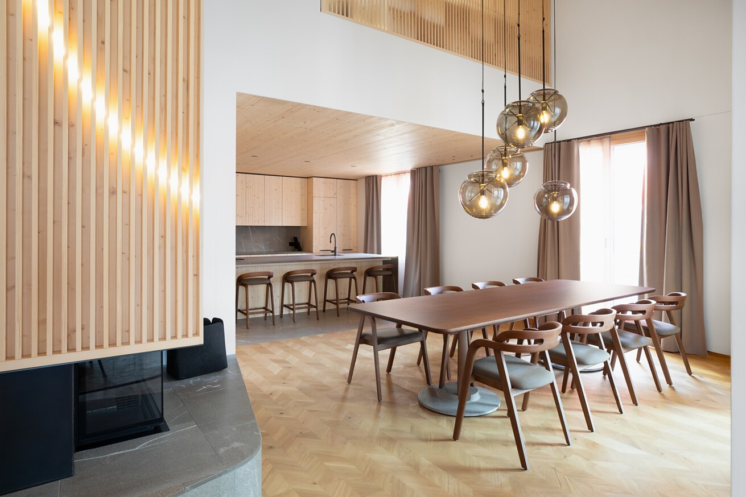

As early as the project's planning phase, close cooperation between CAS Architektur AG and the architecture and design firm atelier oï produced a coherent overall concept that harmonised the exterior and interior of Vera Apartments. Indoors, the Spinpark parquet collection by Bauwerk Parkett, which the Swiss manufacturer developed with atelier oï, adds dynamic accents.
Perched on the picturesque mountain landscape in the popular Furkagasse district of Andermatt, a locality in the Swiss Alps, Vera Apartments is a modern interpretation of the traditional Swiss chalet. The ‘gold-coloured wood’ used for the facade reflects nature's gentle forms: as Helen Chappuis of CAS Architektur AG explained, “it is inspired by wind, water and the smooth outlines of a snowy landscape”. The building's gleaming facade sits on a massive natural-stone plinth, serving as an homage to its natural environment.
The large windows and balconies create a close connection between the indoors and outdoors, let abundant light into the living spaces, and open views of the surrounding mountain landscapes. The deep window jambs and the simple, dark window blinds offer a balanced contrast to the light-coloured wooden facade. With its projecting eave, the gabled roof highlights the building’s Alpine character. For CAS Architektur AG, local materials, such as wood from the canton of Uri and natural stone from Ticino, represent the dialogue between central and southern Switzerland.
Tradition, luxury and craftsmanship working hand in hand
The nine residences, including two double-storey penthouses, combine exclusive furnishings and high-quality materials, standing out for their loft style and open floor plans. The interior design was conceived by atelier oï. It seeks to create a balanced interaction of Alpine tradition, contemporary design and haute-couture influences. Distinctive elements were integrated to convey warmth and cosiness, such as the traditional fireplace made of natural stone. Inspired by those magic moments “when the sun rises or sets behind the Alps”, atelier oï developed unique wall elements that filter the light, flooding the rooms with warm radiance.
The loving attention to detail makes itself visible here, too, through the use of local materials that represent the raw beauty of the surrounding landscape. Custom interior objects, including hand-made built-in pine furniture and artful lights made of hand-blown Murano glass, emphasise the quality of the craftsmanship. Natural-stone floors in the kitchens and bathrooms complement the high-value interiors, contrasting the warm wood used for the furniture and the floors. All this results in a living concept that is deeply rooted in local nature while satisfying the highest expectations for aesthetics.
This can be clearly seen in the elegant furniture and accessories by atelier oï, which combine fashion sense with indoor architecture. It is also reflected in the Spinpark parquet collection, created through close collaboration between atelier oï and the Swiss parquet manufacturer Bauwerk Parkett.
Dynamic and natural aesthetic
Spinpark stands out with its 45-degree rotation of the wood grain relative to the plank, which gives rise to new geometric patterns and floor styles. “Our own design perspective and their profound understanding of ways of working with wood helped us reinvent typologies and develop innovative patterns,” said Aurel Aebi, co-founder of atelier oï, describing the fruitful collaboration with Bauwerk Parkett.
Laid in the popular chevron pattern inside the apartment building, Spinpark adds a dynamic, natural aesthetic to the rooms: “With its multi-faceted colour palette and fine patterns, this parquet format creates a natural frame that enriches its environment,” Aebi explained. “Its unmistakable pattern turns the floor into an active participant in the space, as the interplay of texture, light and colour gives it a palpable presence.” Thus, Spinpark serves as an elegant stage for the building's high-quality interiors. In addition to quality in terms of aesthetics and function, environmental responsibility plays a key role in the apartment building’s architecture.
Environmental responsibility
Certified in accordance with the Minergie standard, the building becomes a clear statement for sustainable construction, which manifests itself in the local materials used and other aspects. Thus, the choice to opt for sustainable, Swiss-made quality oak parquet by Bauwerk Parkett was only natural. The 100% healthy-living Spinpark parquet can be found in the apartment building's living and bedroom spaces. Cleverpark 900 was used for the stairs. The natural-oiled authentic-wood floors by Bauwerk Parkett carry the ecobau and the French VOC labels, having successfully passed testing by eco-INSTITUT and Sentinel Holding Institut and other institutions.
The conscious selection of materials and careful choice of hand-crafted furnishings underscore the project's core architectural themes. The Vera Apartments building impressively demonstrates how architecture can develop by both respecting its roots and introducing innovative design concepts, as well as making use of the beauty of its surroundings at the same time.
Details and facts
Project: Vera Apartments, Andermatt (CH)
Property owner: Andermatt Swiss Alps AG, Andermatt (CH)
General contractor: CAS Realisierung AG, Kriens (CH), cas-gruppe.ch
Architects: CAS Architektur AG, Kriens, (CH), cas-gruppe.ch
Interior design: atelier oï, La Neuveville (CH), www.atelier-oi.ch
Completion: Early 2025
Bauwerk Parkett: 550 m² Spinpark Oak Nature, stairs with Cleverpark 900 Oak Nature
Installation partner: Deluxe Parkett, 6023 Rothenburg (CH), www.deluxe-parkett.ch
Interior photographs: atelier oï
Exterior photographs: CAS Architektur AG
For press enquiries, please contact
Rainer Häupl
bering*kopal GbR, communications agency
P + 49 (0) 711 74 51 75916
rainer.haeupl@bering-kopal.de
www.bering-kopal.de
St. Margrethen (CH), April 2025
Reprint free of charge/specify source

1 The custom built-in pine furniture and hand-made lights create a warm and inviting atmosphere. Photo: atelier oï
2 Vera Apartments in Andermatt is an outstanding example of a successful symbiosis of traditional Swiss chalet architecture and contemporary design. With its arched, gold-coloured wooden facade and massive natural-stone plinth, it smoothly blends in with its Alpine environment.
Photo: CAS Architektur AG
3 The use of local materials, such as natural stone from Ticino and wood from the canton of Uri, underscores the project’s references to nature and its sustainability. Photo: atelier oï
4 Thanks to its distinctive chevron look, the high-quality Spinpark oak parquet by the Swiss manufacturer Bauwerk Parkett adds a dynamic and, at the same time, natural aesthetic to the living and bedroom areas.
Photo: atelier oï
1. |  | 2.
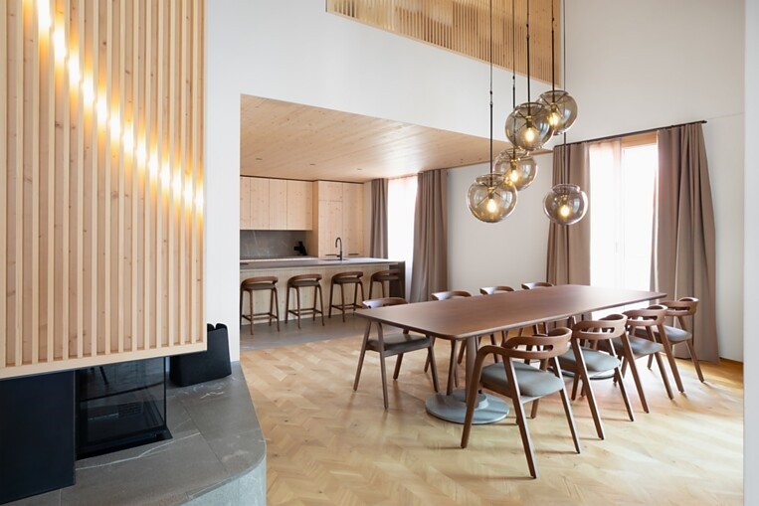 |  | 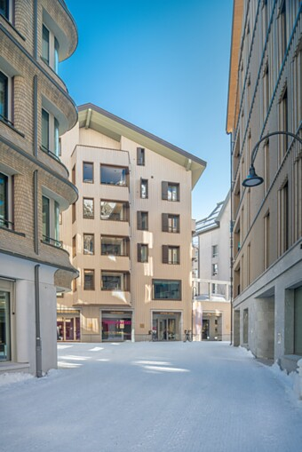
3. |  | 4.
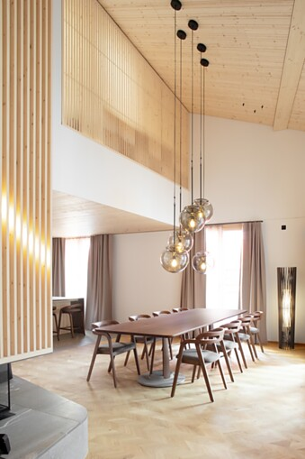 |  | 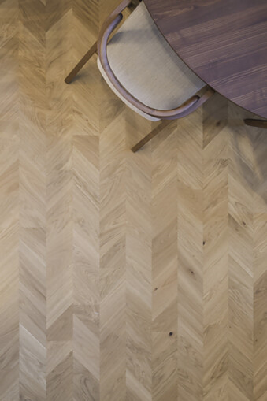

5 Bauwerk Parkett developed the parquet collection together with the renowned Swiss architect and design firm atelier oï. Spinpark stands out for its 45-degree rotation of the wood grain relative to the plank, giving rise to new geometric patterns and floor styles. Photo: atelier oï
6 Inspired by those magic moments “when the sun rises or sets behind the Alps”, atelier oï, responsible for the interior design, developed unique wall elements for Vera Apartments. They let abundant amounts of warm light into the rooms. Photo: atelier oï
7 The nine residences and penthouses impress with their exclusive furnishings in which Alpine tradition meets modern design elements. Ornate suspended lights made of hand-blown Murano glass emphasise the craftsmanship's quality. Vera Apartments offers an exclusive living experience in the heart of the Swiss Alps. Photo: atelier oï
5. |  | 6.
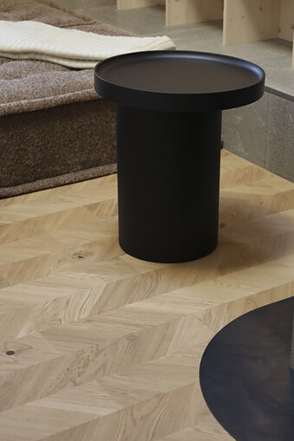 |  | 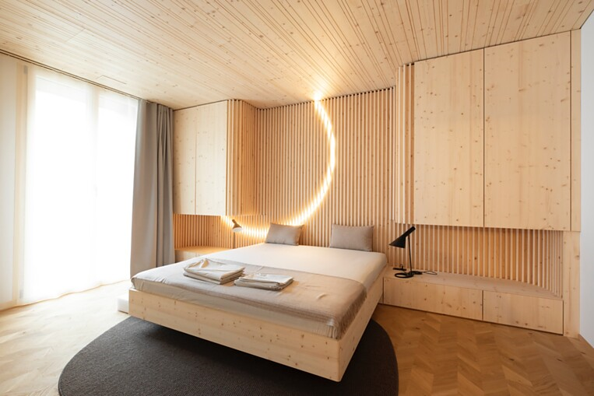
7.
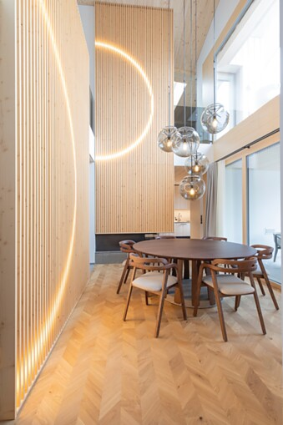

Bauwerk Parkett – Built for a lifetime
What began in 1935 with the invention of solid parquet by Swiss pioneer Ernst Göhner is still setting new standards for ambitious design and healthy living today. Just like every tree and every piece of wood, each of our responsibly manufactured planks is sustainable and unique. A fusion of Swiss engineering and authentic nature results in extraordinary living experiences: today, and for future generations.
bauwerk-parkett.com

