Daring, Decent, Distinctive
40 years of a+r Architekten: Thinking boldly, planning precisely, and approaching every project with fresh eyes – a credo that has shaped the practice from the very beginning.
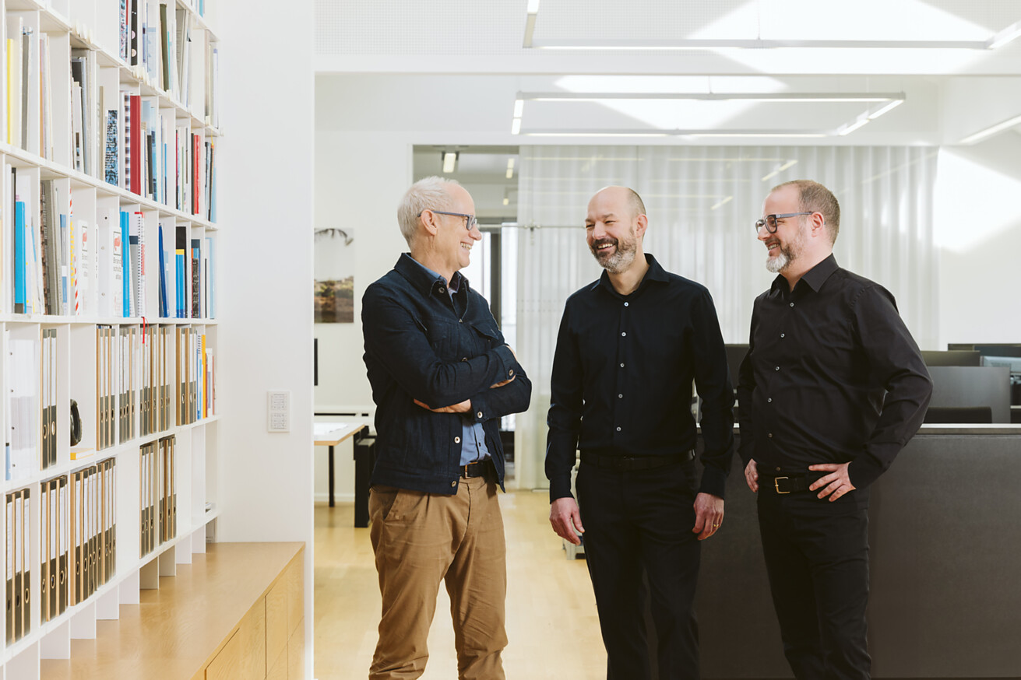

It has been four decades since Gerd Ackermann and Hellmut Raff put their first design to paper in their jointly established architectural practice. Today, when you step into the offices of a+r Architekten, you immediately sense: this is not a place of self-promotion, but of substance. A place where solutions are sought that not only work but feel right. And a team that doesn’t view architecture as a matter of style, but as an engagement with place, context and people.  The practice was founded in 1985 by Prof. Gerd Ackermann and Prof. Hellmut Raff – two individuals who regard architecture as a societal responsibility. From this original partnership emerged one of the most dynamic architectural practices in southern Germany: a+r Architekten. Today, around 130 people work at its two office locations – in Stuttgart and Tübingen – jointly developing projects that show attitude and set standards without needing to raise their voice.  Principles endure – the standards rise  What began with a few low-budget projects is still guided by the same principles today: to build simply, purposefully and resource-consciously. From the outset, the practice has never aspired to developing a recognisable design vocabulary. Instead, it focuses on reading the site, on a deep understanding of scale, topology, history and neighbourhood. Context is the compass, not the backdrop. The projects in Myanmar, where a+r collaborated with local craftspeople and villagers to evolve regional building techniques, exemplify this approach.  From the mid-1990s onwards, urban planning issues came increasingly into focus: How can public, semi-public and private spaces be interwoven? How can high-quality, urban open spaces be created that encourage social intermixing and an open urban society? Milestone housing projects such as the Rosenstein Quarter in Stuttgart – regarded as a model for sustainable urban development – have shaped the practice’s direction and public profile. Over the years, a number of educational buildings have followed, each with their own specific requirements. A characteristic example is the grammar school with sports hall and youth centre in Frankfurt-Riedberg – a large school campus for 1,350 pupils, whose architectural concept translates the programme into a human scale and interweaves learning, physical activity and social interaction. Another current example is the Neufreimann education campus in Munich: With two schools, each with six classes per grade, for around 2,000 children and young people, several sports halls, a school swimming pool, a nursery, a cafeteria and extensive outdoor facilities, it is among the largest and most complex school building projects currently underway in the city. As in Frankfurt-Riedberg, a comprehensive spatial programme is transformed here into a clear, user-focused structure – functional, precise in terms of urban planning and with the aim of making education tangible as a social space.  The early integration of the next generation into the management team played a key role in shaping today’s leadership – long before the founding partners officially retired. Oliver Braun, Florian Gruner and Alexander Lange. Together with Walter Fritz, who was a partner at a+r from 2010 to 2025, they guided the firm’s transformation from a 20-person office into the company it is today – while developing a remarkable way of working together.  Not iconic. Individual.  There is no universally recognisable design signature, no “a+r look” that is applied across the board to all projects. Architecture, the team firmly believes, must evolve from its place, not from a desire for recognition. The result is solutions with depth, character and precision – whether school, office building, housing project, church or cultural institution. The team of architects analyses, interprets, scales – and keeps thinking. From the accurate urban master plan down to the smallest detail. “You might call us straitjacket planners,” says Alexander Lange with a smile. “We need clear boundary conditions in order to flourish in our work.” This approach leads to buildings that integrate seamlessly into their context and are yet unmistakable – like the cultural centre Kulturbahnhof Aalen (KUBAA), a beacon project for adaptive reuse and a hub for culture and community. “We believe you can tell whether a project has been created with joy,” says Oliver Braun about the team spirit that runs through each project: “With joy in designing, in collaboration, and in implementation.”  Driven by competition  a+r Architekten are competition architects – with heart and soul and an impressive track record. For years, they have ranked among the most successful practices in the German-speaking world. Over the past decade, they’ve consistently placed in the top 10 of the Competitionline ranking, reaching number 1 in 2020 and currently standing at fourth place. Around 50 competitions per year, with 8 to 10 wins – that’s not just a discipline, it’s top-level sport. “We play to win. Just taking part isn’t enough,” encapsulates Oliver Braun. This isn’t about vanity – it’s about ambition. Every competition is a new challenge, a new opportunity to design something special. The fact that no one ends up sleep-deprived and carving models at the last minute is a crucial part of their success: at a+r, good architecture doesn’t happen under pressure but in flow.  Principles over personalities  What sets the practice apart is how people treat one another and the task at hand. One phrase comes up often: “confident humility.” It may sound cumbersome, but it captures the essence of a+r’s self-image. The architects don’t consider themselves creators, but interpreters – of requirements, places and visions. No gestures for gesture’s sake. No power games with clients. Instead: dialogue, discipline, and sometimes respectful disagreement. Lessons have also come from setbacks. “You have to learn to lose before you can win,” says Florian Gruner, who oversees the later HOAI service phases within the leadership team. And mistakes aren’t brushed aside – they’re analysed. That’s another thing that makes the office so vibrant: a culture of constant learning shaped by openness. Observing, discussing, improving – even when first prize is already all sewn up.  Courage is part of the method  Even in times when the construction industry is faltering, a+r Architekten remain proactive. They think projects differently – boldly and precisely, without losing themselves in speculation. Living above the opera, for example – a village on the rooftop of Stuttgart’s temporary opera house – isn’t utopia for the a+r team, it’s lived reality. Their experimental approach relies on their client’s courage just as much as the planners’ analytical expertise – especially in housing construction. “We have to completely rethink floor plans,” says Alexander Lange. “The traditional living room is often unnecessary. Instead, we need central, flexible spaces – compact, efficient and yet of high quality.”  What’s next? Keep going.  The office’s focus is on the future, not the past. “A high-rise would be nice,” says Oliver Braun. “Or a mountain hut,” adds Alexander Lange. One for the view, the other for the simplicity. Both are expressions of the same idea: architecture starts in the mind and grows through collaboration. And when it’s nurtured, as it has been at a+r, with such energy, joy and skill over decades, then an anniversary is not a retrospective – but a springboard. Into the next 40 years of architecture – with attitude, heart and a rhythm all of its own.  Stuttgart, July 2025  Reprint free of charge / specimen copy requested | Your press contact  Rainer Häupl  bering*kopal GbR, Büro für Kommunikation  t +49(0)711 7451759-16  rainer.haeupl@bering-kopal.de  www.bering-kopal.de  Architects contact  a+r Architekten GmbH  Julia Raff  Rotebühlstraße 89/2  D 70178 Stuttgart  t +49(0)711 722355-31  f +49(0)711 722355-22  pr@aplusr.de  www.aplusr.de

1 40 years of a+r Architekten – not the end of a chapter, but an invitation to the next 40 years shaped by attitude, humour and a clear eye for what matters most. Pictured (left to right): Managing Directors Alexander Lange, Florian Gruner and Oliver Braun. Photo: Alex Dietrich
2 Gerd Ackermann and Hellmut Raff in the early years of their architectural partnership – a joint departure shaped from the outset by a clear attitude, a pursuit of simplicity and precision, and a deep belief in architecture as a societal responsibility. Photo: a+r Architekten
3 What distinguishes a+r is not just their designs, but the culture behind them. No ego-driven “one-person shows” – instead, team players. Excursions, skiing trips, spontaneous barbecues and other social events are, of course, all part of it. This cuture is also reflected in the way young colleagues are treated, whose input is expressly encouraged and taken seriously. Photo: a+r Architekten
4 Durable materials – ecological, honest, lasting, as used in the multi-award-winning Burma Hospital in Myanmar completed in 2020 – have always stood for a+r Architekten’s architecture that is committed to responsibility, durability and the respectful use of resources. Photo: Oliver Gerhartz
1. |  | 2.
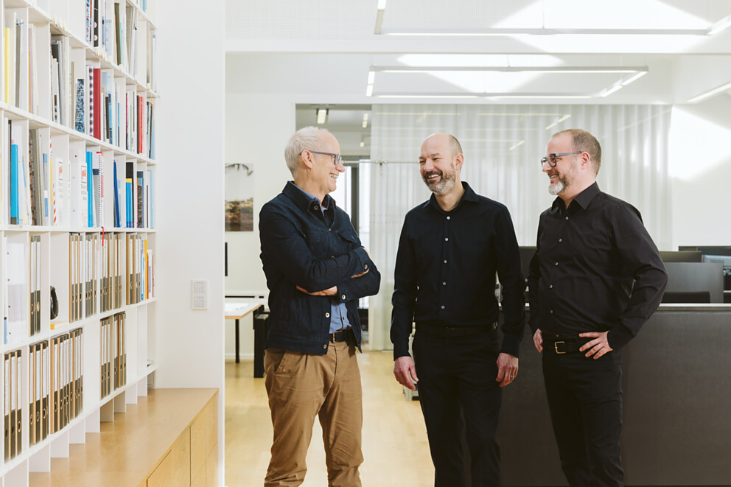 |  | 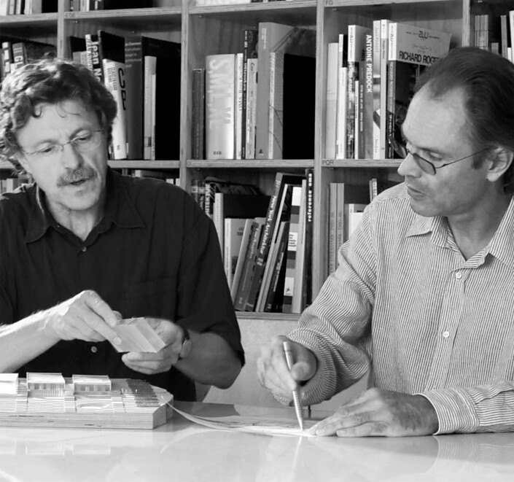
3. |  | 4.
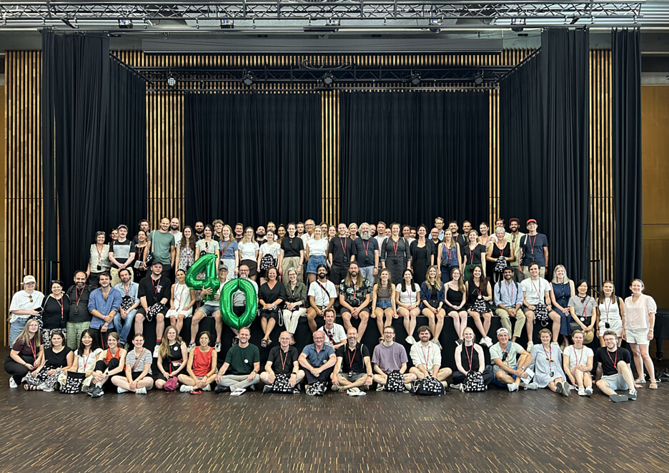 |  | 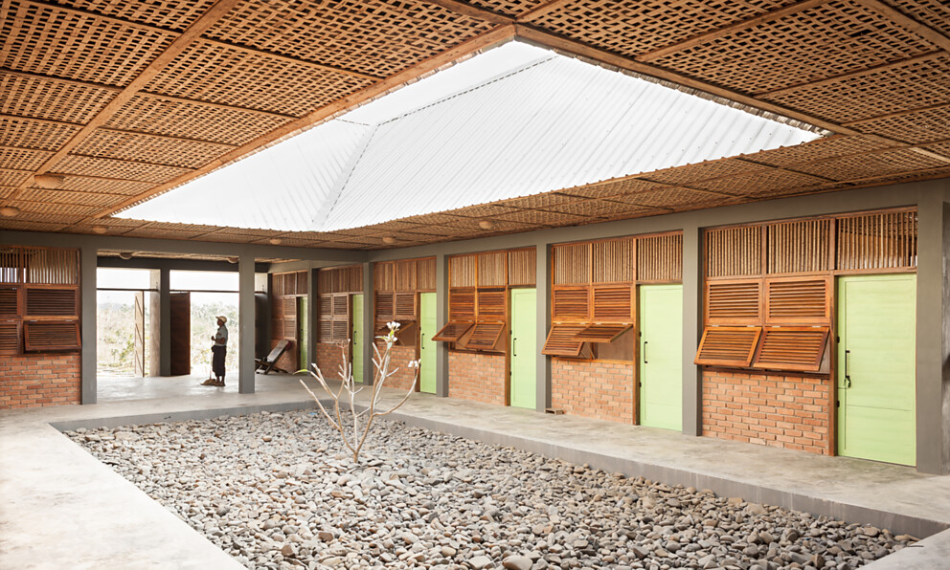

5 The housing development in Stuttgart’s Rosenstein Quarter, completed in 2018, is a model for sustainable urban development. The project – recognised with multiple awards – relies on energy sources such as ice storage, photovoltaics and solar thermal energy, combined with homogeneous perimeter block development, green courtyards and a high level of permeability. Photo: Brigida González
NOTE: The use of this photo is free of charge for editorial reporting on the 40th anniversary of a+r Architekten during the current year. Any use for advertising purposes or corporate publishing is expressly excluded and requires prior written permission.
6 Riedberg Grammar School in Frankfurt is part of the city’s urban development in the northern districts. Whether neighbourhood, university or school campus – a+r always thinks in spatial terms and responds with social awareness. The cluster-based typology, each with its own atrium, translates the large school complex for 1,350 pupils into a manageable structure. Restrained architecture, clearly structured open spaces and the passive house standard characterise the design implemented in 2013. Photo: Thomas Herrmann
NOTE: The use of this photo is free of charge for editorial reporting on the 40th anniversary of a+r Architekten during the current year. Any use for advertising purposes or corporate publishing is expressly excluded and requires prior written permission.
7 In the heart of a new urban quarter, one of Munich’s largest school sites is taking shape: the Neufreimann Education Campus. It will house two schools with six classes per grade each, sports halls, a swimming pool, a nursery and terraced roof landscapes. The campus design by a+r Architekten translates the complex spatial programme into a clear urban structure and allows education to be experienced as part of the urban fabric. Photo: Brigida González
NOTE: The use of this photo is free of charge for editorial reporting on the 40th anniversary of a+r Architekten during the current year. Any use for advertising purposes or corporate publishing is expressly excluded and requires prior written permission.
8 The joy in designing with and for people is central to a+r Architekten’s architectural approach – combining attitude, quality and team spirit. The result is outstanding projects such as the Aalen Kulturbahnhof, opened in 2020. The flagship project sensitively translates the industrial history of the location into contemporary architecture. Photo: Brigida González
NOTE: The use of this photo is free of charge for editorial reporting on the 40th anniversary of a+r Architekten during the current year. Any use for advertising purposes or corporate publishing is expressly excluded and requires prior written permission.
5. |  | 6.
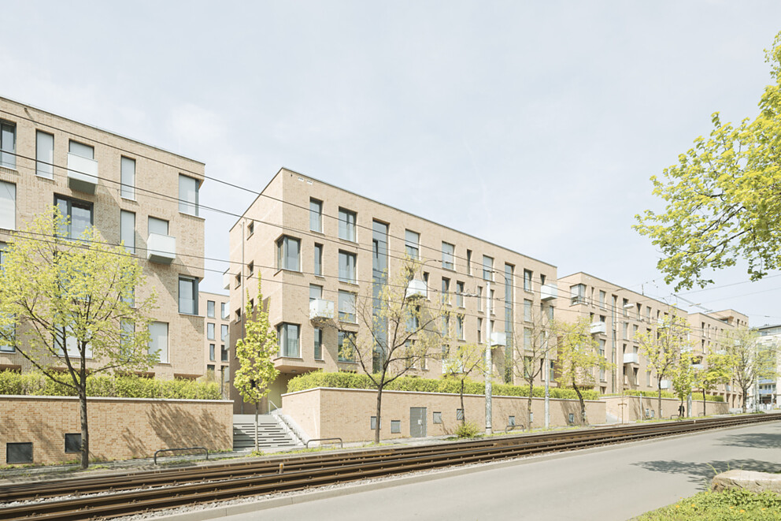 |  | 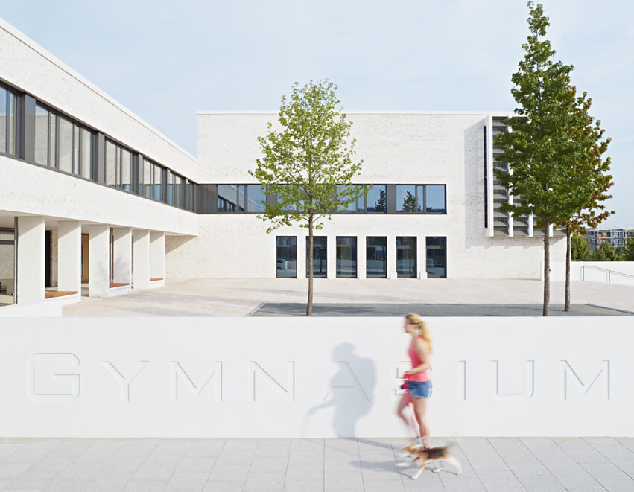
7. |  | 8.
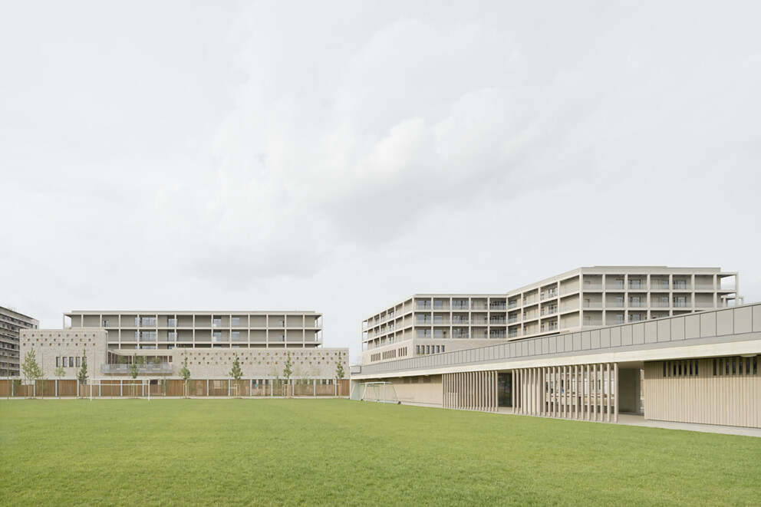 |  | 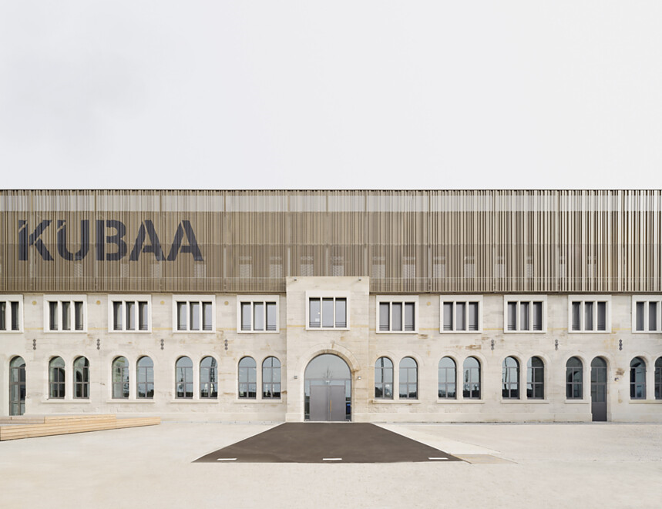

9 The winning design by a+r Architekten and NL Architects in the 2023 closed competition for the Stuttgart Opera’s interim venue combines technical precision with a visionary urban planning concept. A reusable opera auditorium is accompanied by other spaces designed for later repurposing – topped by a “village on the roof”. Visualisation: Vivid Vision
10 With the construction of the new Technical Town Hall in Tübingen, a+r Architekten created a citizen-centred administrative building in a resource-efficient design. Clean forms, functional structures and a sensitive urban response define the 2021 project. It was recognised for its design quality and sustainability by the Baden-Württemberg Chamber of Architects in the “Exemplary Building in the Tübingen District (2017–2025)” competition. Photo: Marcus Ebener
NOTE: The use of this photo is free of charge for editorial reporting on the 40th anniversary of a+r Architekten during the current year. Any use for advertising purposes or corporate publishing is expressly excluded and requires prior written permission.
11 Sculptural and monolithic – that’s the first impression of the new headquarters of the long-established company Gustav Epple, which has been driving developments in the construction sector for over 100 years. This forward-thinking attitude towards building is clearly expressed in the new building, completed in 2021 in Stuttgart’s Tränke industrial estate. Photo: Max Leitner
12 A new identity-generating building at the junction of avenue, river and fairground – the Festhalle Neckarallee features a striking timber roof structure, open spatial layout and strong landscape integration. In use since 2013, it serves the local community of Neckartailfingen. Photo: Thomas Herrmann
NOTE: The use of this photo is free of charge for editorial reporting on the 40th anniversary of a+r Architekten during the current year. Any use for advertising purposes or corporate publishing is expressly excluded and requires prior written permission.
9. |  | 10.
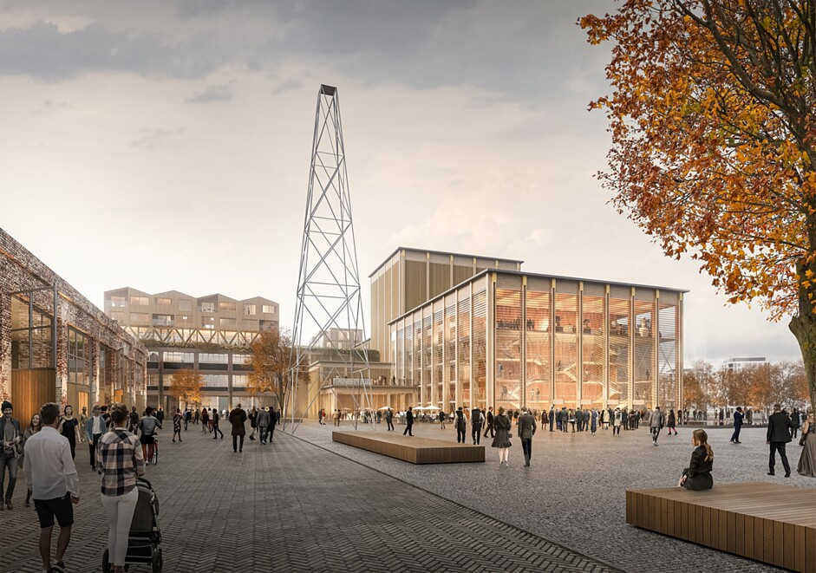 |  | 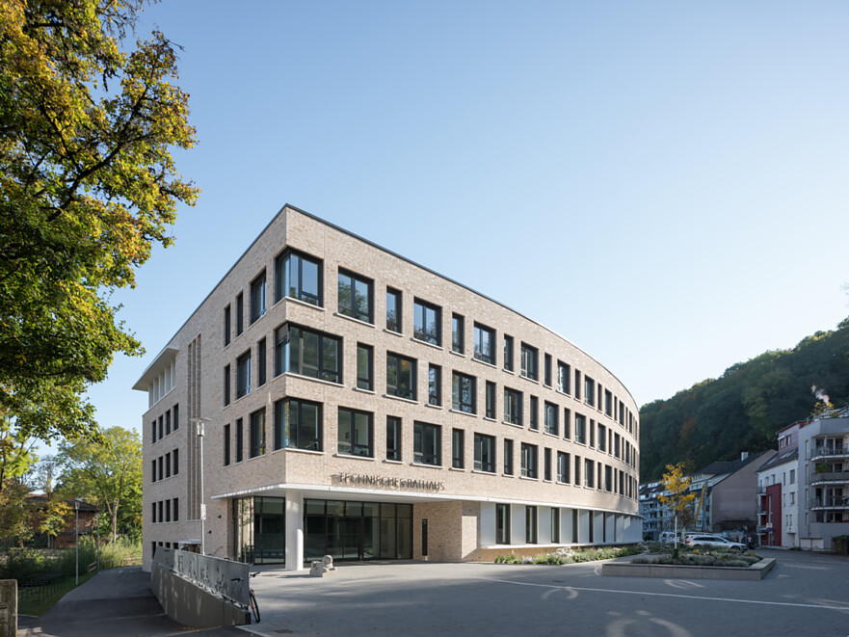
11. |  | 12.
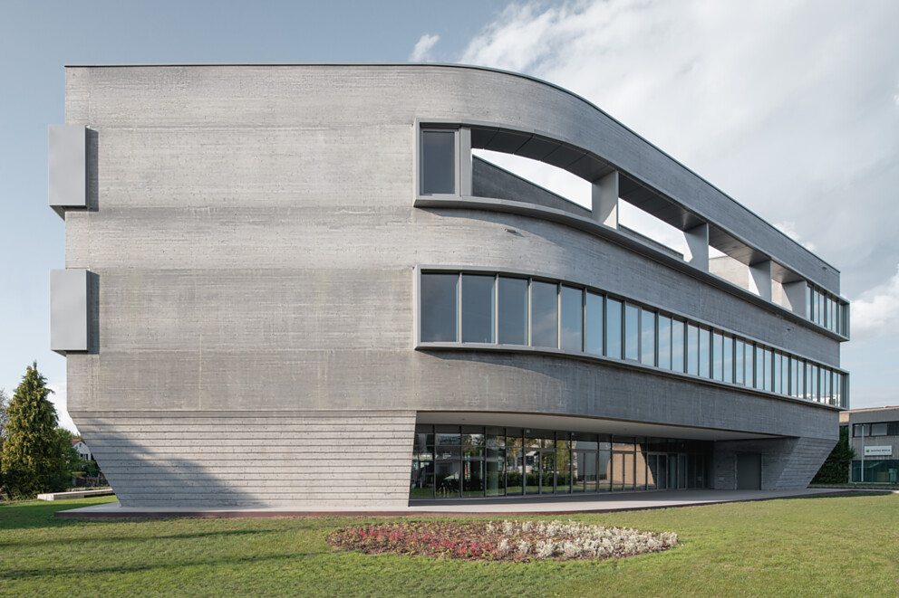 |  | 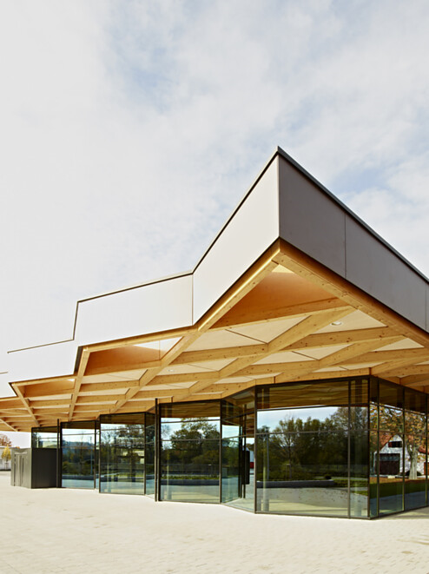

13 The more than 100-year-old Pfahlbaumuseum on Lake Constance offers insights into 3,000 years of human history. The striking element of the Pfahlbaumuseum visitor centre by a+r Architekten, opened in 2024, is its open timber roof truss – an expressive under-tensioned frame construction made of glulam.
NOTE: The use of this photo is free of charge for editorial reporting on the 40th anniversary of a+r Architekten during the current year. Any use for advertising purposes or corporate publishing is expressly excluded and requires prior written permission.
14 Perched on an exposed slope, the award-winning New Apostolic Church in Pliezhausen – completed in 2016 – presents itself as a sculptural standalone structure. The inclined nave rises towards the street, while the pigmented lightweight concrete walls with deep reveals and fine texture echo the region’s tuff stone. Photo: Marcus Ebener
NOTE: The use of this photo is free of charge for editorial reporting on the 40th anniversary of a+r Architekten during the current year. Any use for advertising purposes or corporate publishing is expressly excluded and requires prior written permission.
15 Context is the compass, not the backdrop: With its extension building at Alter Postplatz, the Rems-Murr District Office has consolidated its locations, increased efficiency and set new standards in contemporary administrative architecture. Completed in 2025, the polygonal new building impresses with its sustainable timber-hybrid construction, a forward-looking spatial concept and strong urban sensitivity. Photo: Brigida González
NOTE: The use of this photo is free of charge for editorial reporting on the 40th anniversary of a+r Architekten during the current year. Any use for advertising purposes or corporate publishing is expressly excluded and requires prior written permission.
13. |  | 14.
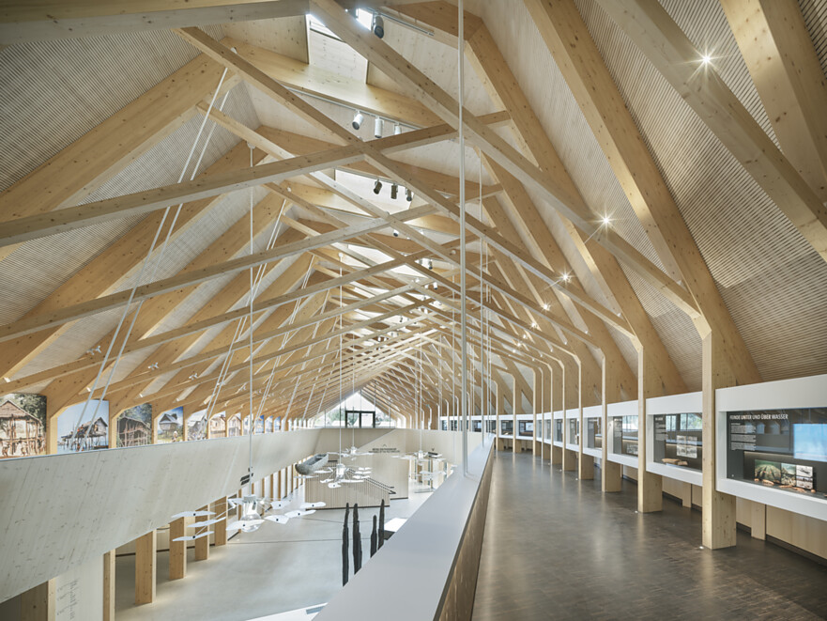 |  | 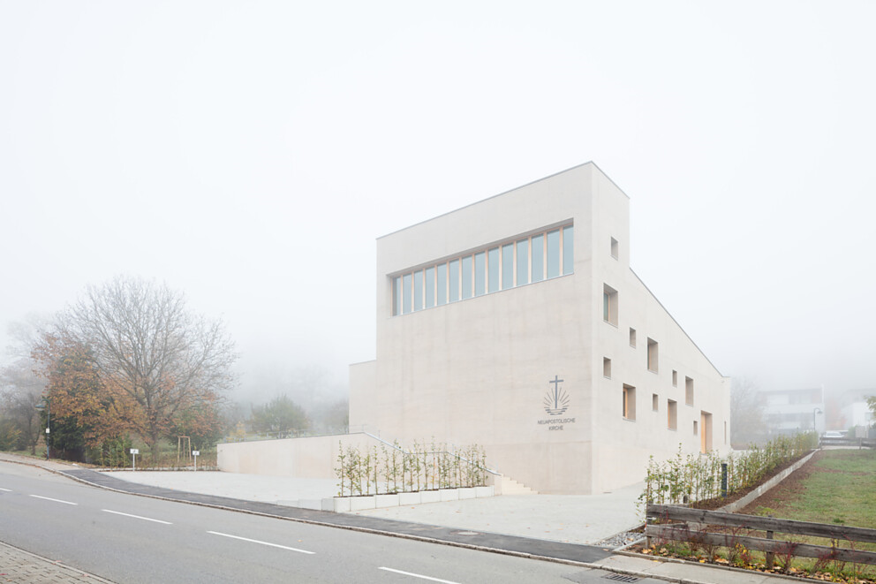
15.
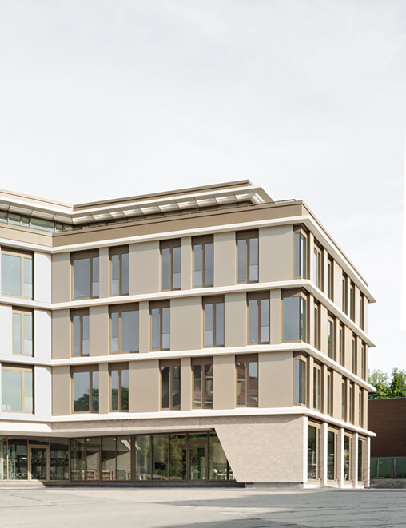

About a+r Architekten
a+r Architekten stand for solid, environmentally compatible and future-oriented architecture with impressive expertise in the field of sustainable building — also in existing building contexts. Founded in 1985 by Professor Gerd Ackermann and Professor Hellmut Raff, the office with branches in Stuttgart and Tübingen has around 130 employees and is today headed by Oliver Braun, Florian Gruner and Alexander Lange. a+r Architekten mainly build for public clients, industry and commerce, municipal housing companies and social institutions. The office focuses on appropriate, ecological, functional and the resulting innovative construction methods and has been awarded prestigious prizes for this approach.
www.aplusr.de
Instagram

