World-Class: Learning Without Borders
With the latest addition to the campus, a+r Architekten complete the Degerloch site of International School of Stuttgart e.V. (ISS).
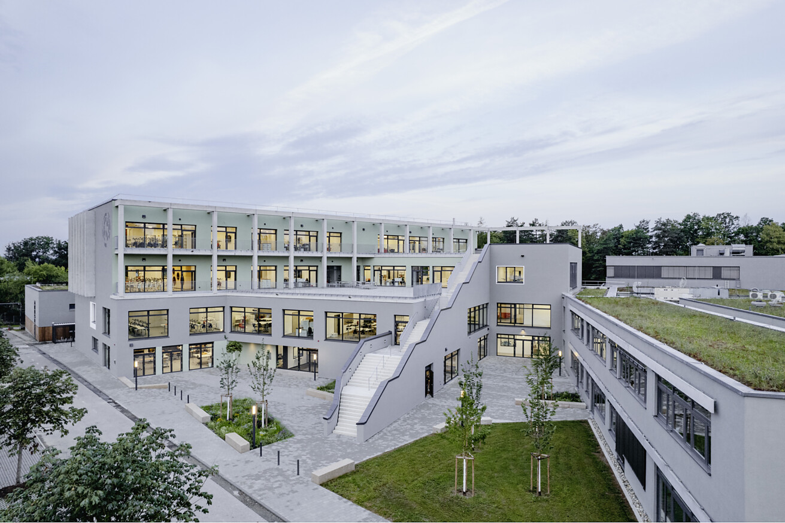

Founded in 1985, the ISS is home to more than 800 students from over 45 countries, making it a vibrant example of lived internationalism. This cosmopolitan approach is also reflected in the school’s architecture: the Degerloch campus features open spaces designed to foster intercultural exchange and collaborative learning. The recently completed extension by a+r Architekten underscores the school’s commitment to a future-oriented educational environment.  The four-storey new building for the International School of Stuttgart (ISS) complements the Degerloch campus as a connecting element between the existing school buildings, which we also designed and implemented in 2001 and 2012. While the southern part of the new structure continues the existing building line, the northern section is terraced and slightly set back. “This layout creates an inviting urban forecourt to the east, while the west side is complemented by sports and schoolyard areas,” explains Johannes Weiß, senior architect at a+r. A distinctive external staircase accentuates the architectural rhythm and connects the different levels, while also functioning as a second escape route.  Basis for the spatial and pedagogical concept  To develop the basis for the extension’s design and spatial layout, we – together with the client – worked in close cooperation with Hamburg-based architect and school construction consultant Kirstin Bartels. She advises both public and private educational institutions on the development of integrated spatial and pedagogical concepts as part of the “Phase Zero” process.  A series of workshops with teachers, students and school representatives laid the foundation for the ISS spatial programme. “A well-conducted Phase Zero is the key to successful school planning and a high-quality, sustainable implementation,” Bartels affirms.  Transparency and transitions  The solid structure with an external thermal insulation composite system (ETICS) is visually softened by generous glazing, allowing natural light to flood the interiors to create a bright and transparent learning environment. The two upper floors open outwards, flowing seamlessly onto expansive terraces. A continuous pergola made of precast concrete elements connects both levels and defines the transition between indoor and outdoor spaces – sometimes serving as a balcony, sometimes as a protective frame element. Towards the street, this design feature becomes more pronounced, forming a prominent bay that extends across both upper levels and adds a vivid depth to the façade.  The heart of the campus  The new entrance on the eastern side opens up to the surrounding area as an urban forecourt, creating a welcoming gesture. The main entrance leads directly into the “new heart” of the campus – a spacious foyer conceived as an open meeting point and central hub of school life. The foyer provides access to the public areas: the Black Box Theatre, a multifunctional event space for performances, concerts, exhibitions and school festivals; as well as to creativity workshops, music and rehearsal rooms, a makerspace and the design cluster. The state-of-the-art IT team space underscores the building’s innovative spirit. The result is a forward-looking learning and living environment that combines functionality and identity.  Innovative learning clusters  A wide main staircase connects the foyer and the first floor, where the “school street” – the barrier-free main circulation area – connects the different parts of the building ensemble. All cluster levels are reached via the main stairwell in the south. These open learning clusters, each combining two to three classrooms with adjoining differentiation spaces to form autonomous learning studios, promote a modern teaching and learning culture.  At the centre of each cluster is an open, multifunctional area with direct views to the outdoors – the vibrant core of each cluster. Niches are designed as so-called “arenas” and “cosy corners”, offering pupils a variety of options for retreat and collaboration. “This design differs from traditional school layouts and, in line with the educational concept of the ‘learning landscape’, promotes open spatial structures that offer a wide range of uses and support both individual and cooperative learning,” explains architect Johannes Weiß. Direct access from each cluster to the terraces located in front further enhances this effect, as the learning environment is expanded to include additional spatial qualities.  Energy-efficient technologies  Sustainability is also a key priority: solar panels supply the classrooms with energy, and a geothermal system ensures efficient heating. Controlled ventilation improves indoor air quality, and a planned vertical garden will boost the building’s environmental performance. Meeting the KfW55 energy standard minimises the energy consumption of the new building.  Architecture as a space for diversity and innovation  The entire architecture of the new building is shaped by a sense of spaciousness. Transparency, openness and visual connections create an inspiring learning environment. The open architecture emphasises the core values of ISS, which stands for an education that embraces cultural diversity and breaks down barriers. It focuses on flexibility and networking, with open learning clusters and generous open spaces creating a close connection between interior and exterior spaces. “This design supports an innovative learning culture and a dynamic, contemporary environment that encourages fresh perspectives and can be felt in every space,” concludes Johannes Weiß.  Data and facts  Project: Extension to the Internationale Schule Stuttgart, 4th construction phase  Client: International School of Stuttgart e.V.  Architecture: a+r Architekten, Stuttgart/Tübingen, www.aplusr.de  Construction period: 02.2022 – 05.2024  Completion: May 2024  GFA: 8,059 m²  GBV: 30,280 m³  Energy standard: KfW55  Photos: Max Leitner  Stuttgart, June 2025  Reproduction free of charge / specimen copy requested | Your press contact  Rainer Häupl  bering*kopal GbR, Büro für Kommunikation  t +49(0)711 7451759-16  rainer.haeupl@bering-kopal.de  www.bering-kopal.de  Architects contact  a+r Architekten GmbH  Julia Raff  Rotebühlstraße 89/2  D 70178 Stuttgart  t +49(0)711 722355-31  f +49(0)711 722355-22  pr@aplusr.de  www.aplusr.de

1 The clean geometry of the four-storey ISS extension is articulated by large windows that convey transparency and create a bright learning environment. A continuous pergola connects interior and exterior spaces, while the wide external staircase links the various levels. Photo: Max Leitner
2 The new building expands and completes the Degerloch campus by connecting the existing school structures, also designed by a+r in 2001 and 2012. Due to the site’s limited space, the recreation and break areas are laid out as terraces on the different floors. Photo: Max Leitner
3 The central foyer and the Black Box Theatre are both fitted with light grey carpeting, creating a warm atmosphere that is further enhanced by timber elements in the stairs, seating, and doors. The wide staircase leads from the foyer to the first floor, where the “school street” provides barrier-free access to all parts of the building. Photo: Max Leitner
4 The minimalist design vocabulary is accentuated by LED light strips that run along the ceiling like graphic lines. The reduced range of materials and colours – matte white walls, light grey carpeting, and anthracite door frames – reinforces the clarity of the space. Photo: Max Leitner
1. |  | 2.
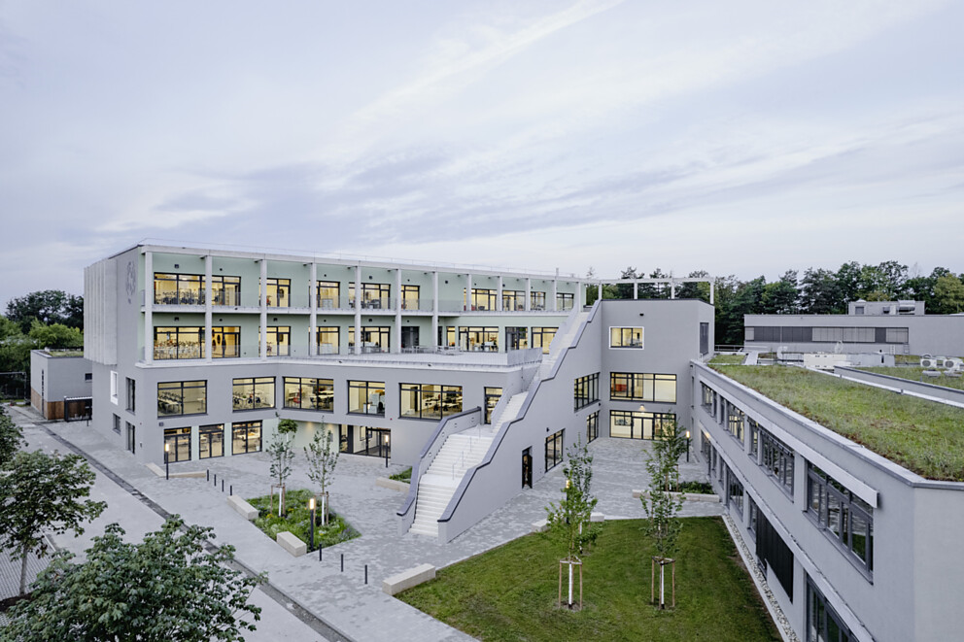 |  | 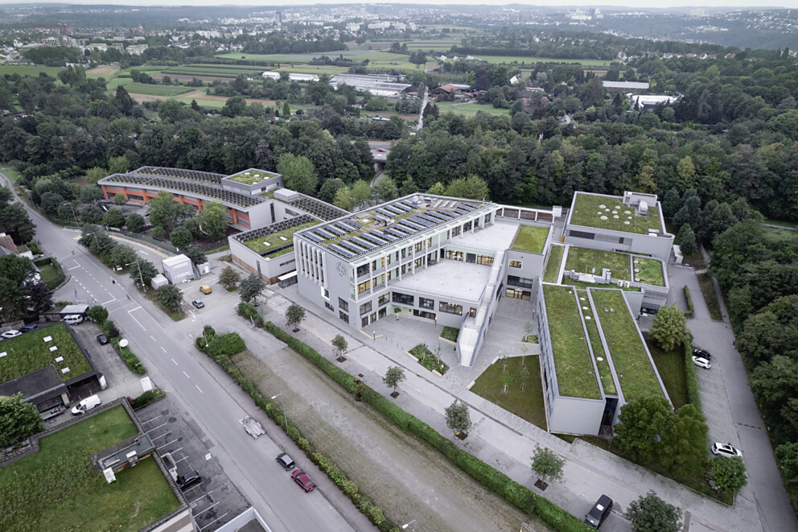
3. |  | 4.
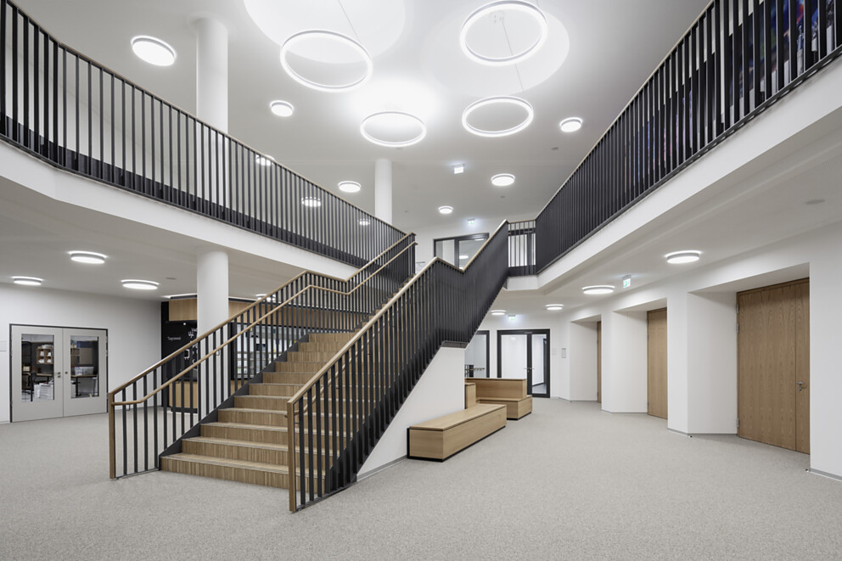 |  | 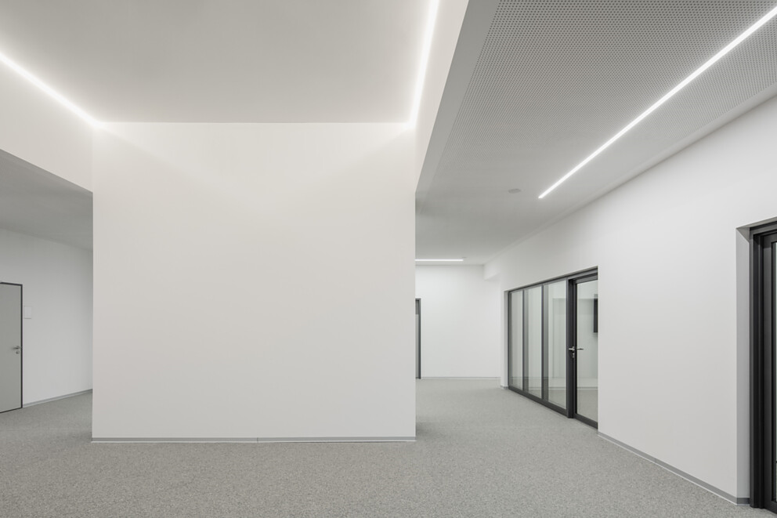

5 Wide corridors and visual permeability create a sense of openness and spaciousness, while geometric LED strips on the ceiling and vertical timber slats provide distinctive design accents. Photo: Max Leitner
6 Another defining feature of the extension is the multi-storey bay, made of precast concrete elements like the pergola, which adds depth and a sculptural effect to the façade. Photo: Max Leitner
7 The urban forecourt marks the new entrance to the school. Generous glazing and articulated terraces result in an open, welcoming architectural expression. The broad external staircase flanks the entrance and connects the building’s various levels. Photo: Max Leitner
8 Site plan of the new extension to the International School of Stuttgart. Drawing: a+r Architekten
5. |  | 6.
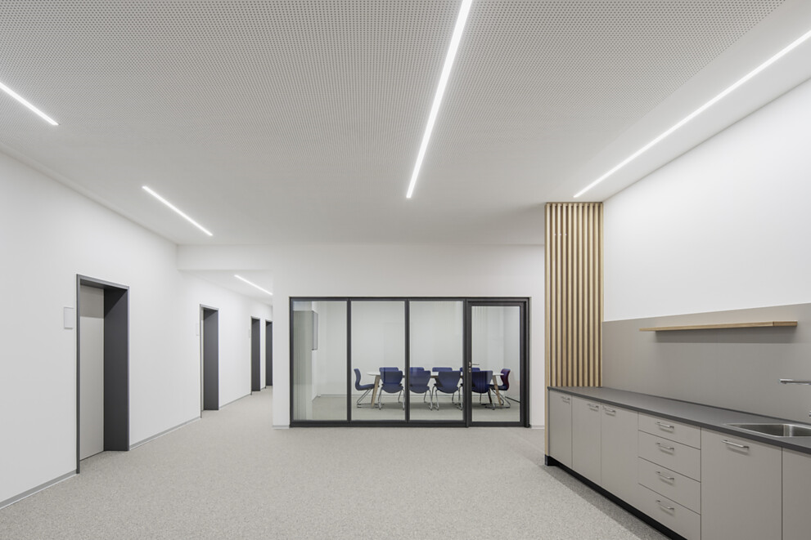 |  | 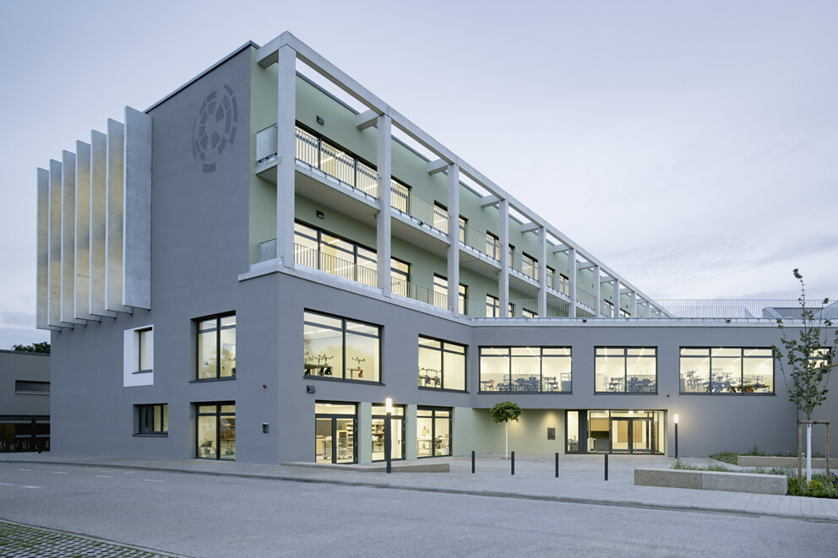
7. |  | 8.
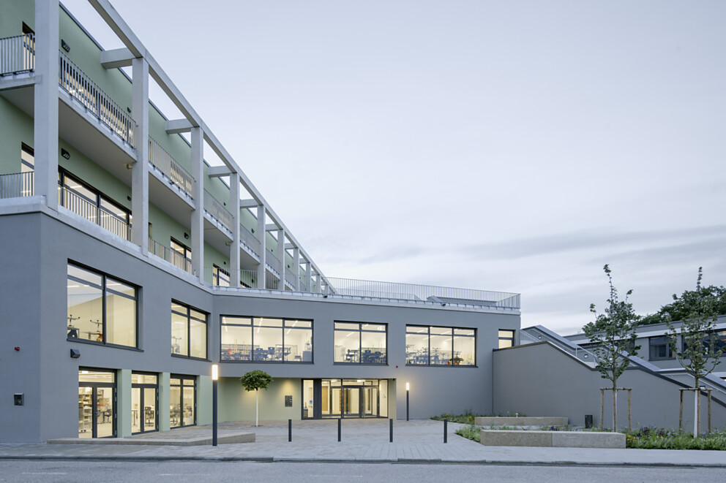 |  | 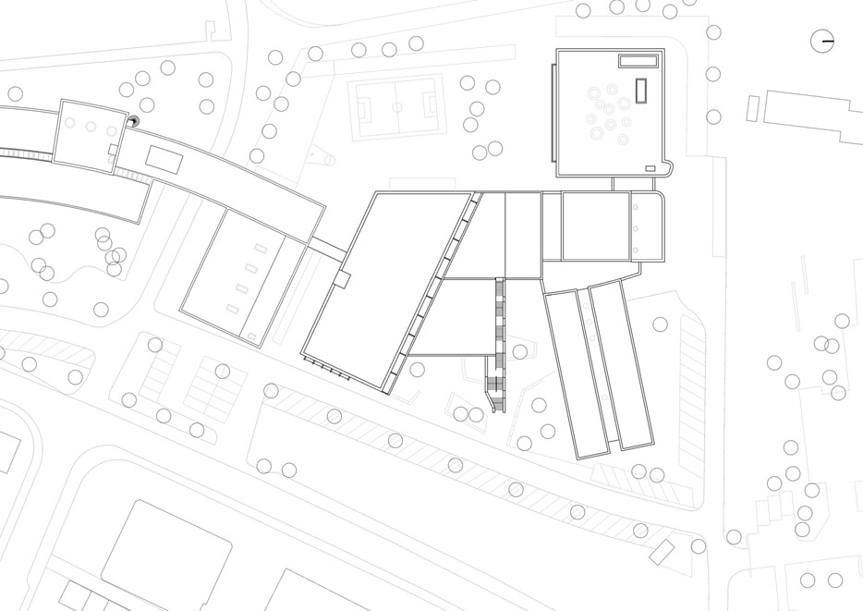

9 Ground floor plan of the extension to the International School of Stuttgart. Drawing: a+r Architekten
10 First floor plan of the extension to the International School of Stuttgart. Drawing: a+r Architekten
11 Second floor plan of the extension to the International School of Stuttgart. Drawing: a+r Architekten
12 Third floor plan of the extension to the International School of Stuttgart. Drawing: a+r Architekten
9. |  | 10.
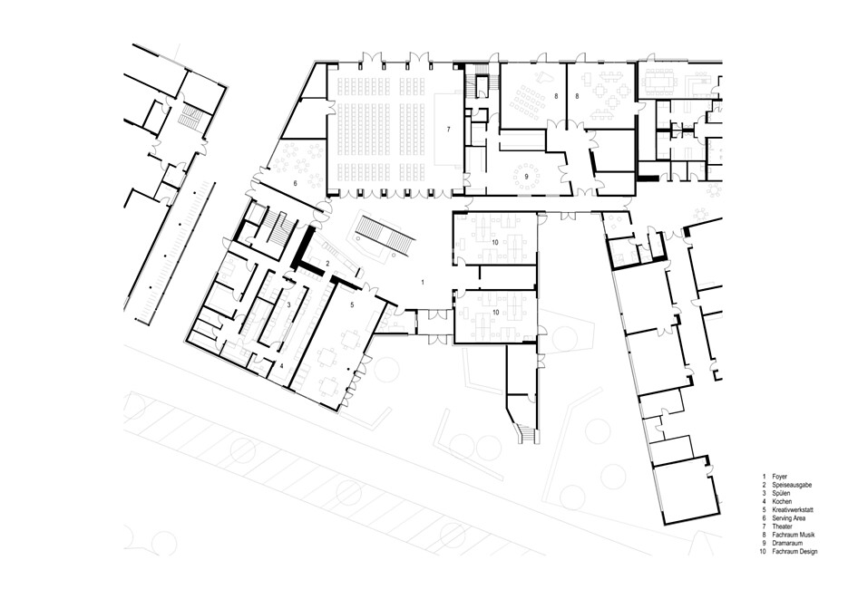 |  | 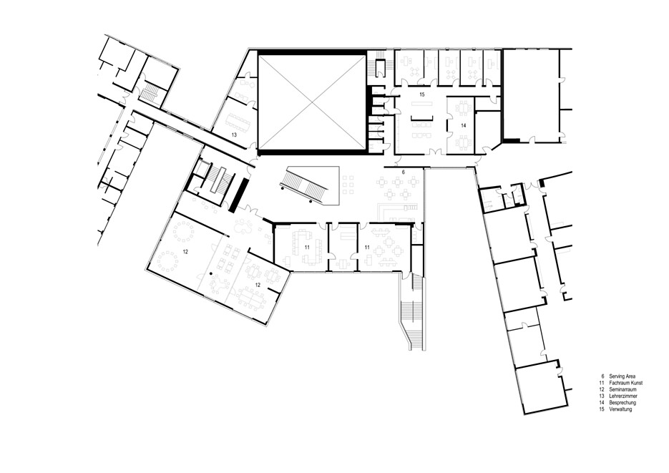
11. |  | 12.
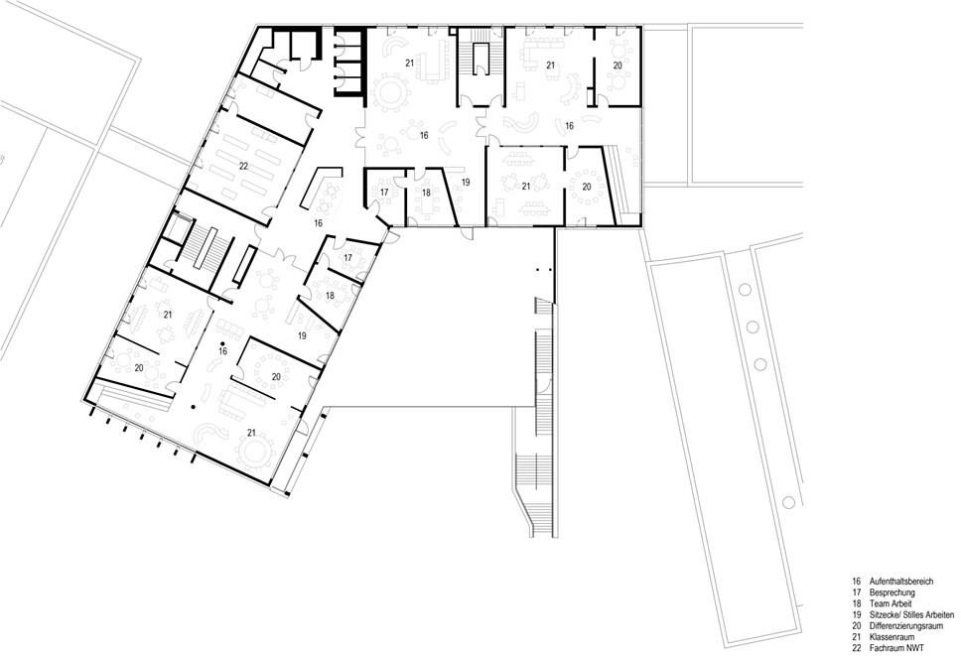 |  | 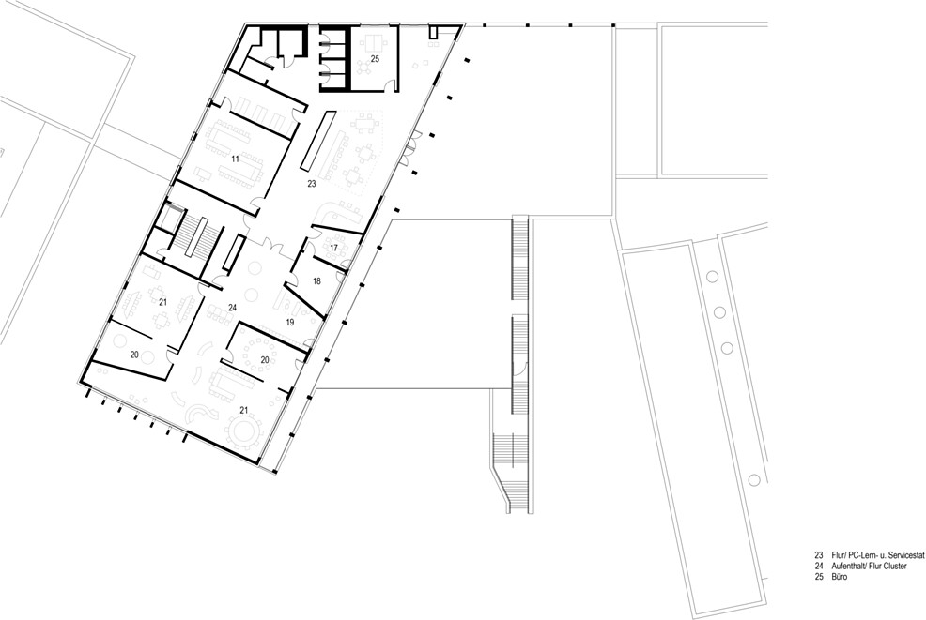

13 Section through the extension to the International School of Stuttgart. Drawing: a+r Architekten
13.
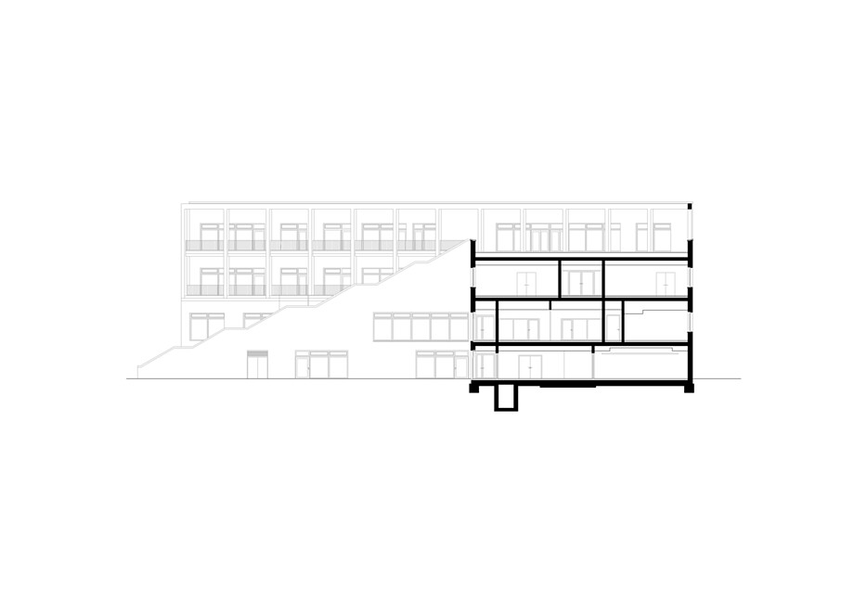

About a+r Architekten
a+r Architekten stand for solid, environmentally compatible and future-oriented architecture with impressive expertise in the field of sustainable building — also in existing building contexts. Founded in 1985 by Professor Gerd Ackermann and Professor Hellmut Raff, the office with branches in Stuttgart and Tübingen has around 130 employees and is today headed by Oliver Braun, Florian Gruner and Alexander Lange. a+r Architekten mainly build for public clients, industry and commerce, municipal housing companies and social institutions. The office focuses on appropriate, ecological, functional and the resulting innovative construction methods and has been awarded prestigious prizes for this approach.
www.aplusr.de
Instagram

